Organic Social Media **Posts**

Thank you for helping us to promote the Healthy Mouth, Healthy Me! campaign. Created by the Georgia Dental Association and its Foundation for Oral Health, this campaign communicates the simple message that a healthy mouth is important to overall health.

By promoting on your social media channels, you can help us amplify the campaign to Georgians, encouraging them to find a GDA member dentist to keep their smiles healthy.

We have seven posts for Facebook and for Instagram that you can share. You can copy and paste the content for those posts from this document. Images for each post can be found on the HealthyMouthHealthyMe.org website.

If you have any questions about the campaign, please contact Carol Galbreath, GDA Senior Director of PR and Communications, 404.636.7553, carol@gadental.org.



# Facebook Posts

**Facebook Post #1: Kyla**

**Post Copy:**

1 in 4 Georgians avoid smiling due to the condition of their mouth and teeth. But not Kyla. At least not anymore. A genetic disorder impacted the health and appearance of her teeth, but, thanks to her dentist, she now has the confidence to smile and take on a new job. [link to HealthyMouthHealthyMe.org]

**Facebook Post #2: Carlos**

**Post Copy:**

92 percent of Georgians believe regular dental visits keep them healthy. Yet not every Georgian sees a dentist regularly. Carlos does. To him, seeing a dentist is just as important as going to his family practice doctor, because his oral health is an essential part of his overall health. Join Carlos and visit your dentist regularly. [link to HealthyMouthHealthyMe.org]

**Facebook Post #3: Deana**

**Post Copy:**

23 percent of adults in Georgia feel embarrassment due to the condition of their mouth and teeth. Deana has no intention of that happening to her. She visits her dentist regularly to make sure she has healthy teeth that last a lifetime. [link to HealthyMouthHealthyMe.org]

**Facebook Post #4: Alison**

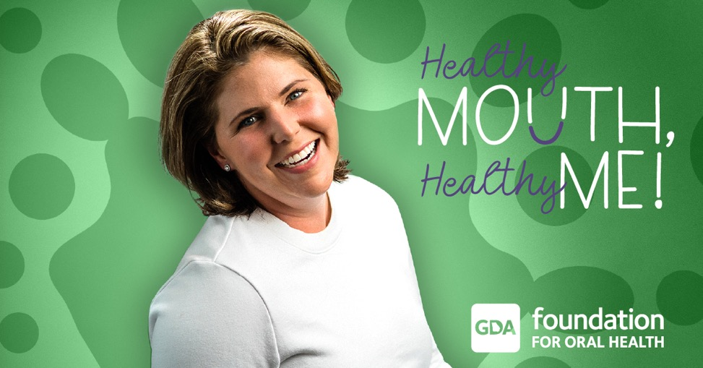

**Post Copy:**

92 percent of Georgians value keeping their mouth healthy. Alison agrees.

Practicing good oral health is important to her overall health. So, she brushes, flosses and sees her dentist regularly. Be like Alison and do it for your health. [link to HealthyMouthHealthyMe.org]

**Facebook Post #5: Sabrina**

**Post Copy:**

92 percent of Georgians believe regular dental visits keep them healthy. Sabrina is one of them. She also believes in the importance of setting a good example for her daughter by brushing and flossing and visiting the dentist regularly. As soon as her daughter is old enough, she’ll start visiting the dentist, too. [link to HealthyMouthHealthyMe.org]

**Facebook Post #6: Jeff**

**Post Copy:**

1 in 4 Georgians say that fear is one of the top reasons they don’t see a dentist regularly.

Jeff is more afraid of what will happen if he doesn’t see a dentist. He wants to avoid cavities and the other issues that come with neglecting oral health. Be like Jeff and visit the dentist. [link to HealthyMouthHealthyMe.org]

**Facebook Post #7: Ava**

**Post Copy:**

30 percent of Georgians experience pain due to the condition of their mouth and teeth.

Ava is happy to no longer be among those Georgians. She realized it was time to take control of her oral health by finding and visiting a dentist regularly. [link to HealthyMouthHealthyMe.org]

# Instagram Posts

**Instagram Post #1: Kyla**

**Post Copy:**

1 in 4 Georgians don’t smile due to the condition of their teeth. Thanks to her dentist, Kyla has regained her confidence. www.HealthyMouthHealthyMe.org

**Instagram Post #2: Carlos**

**Post Copy:**

92 percent of Georgians believe regular dental visits keep them healthy. Carlos is one of them. www.HealthyMouthHealthyMe.org

**Instagram Post #3: Deana**

**Post Copy:**

23 percent of Georgians are embarrassed about the condition of their teeth. Deana sees her dentist regularly to keep her smile healthy. www.HealthyMouthHealthyMe.org

**Instagram Post #4: Alison**

**Post Copy:**

92 percent of Georgians value keeping their mouth healthy. That’s why Alison visits her dentist regularly. www.HealthyMouthHealthyMe.org

**Instagram Post #5: Sabrina**

**Post Copy:**

92 percent of Georgians believe seeing the dentist regularly keeps them healthy. Sabrina does, too. Stay healthy. www.HealthyMouthHealthyMe.org

**Instagram Post #6: Jeff**

**Post Copy:**

1 in 4 Georgians say fear keeps them from visiting the dentist. Jeff fears what will happen if he doesn’t visit the dentist. www.HealthyMouthHealthyMe.org

**Instagram Post #7: Ava**

**Post Copy:**

30 percent of Georgians experience pain because of their teeth. Ava doesn’t anymore. She found a dentist. www.HealthyMouthHealthyMe.org

If you have any questions about the campaign, please contact Carol Galbreath, GDA Senior Director of PR and Communications, 404.636.7553, carol@gadental.org.

